

Section 482 Determination
Building Application Form

Digital Images
Please email this application form together with a small selection of high quality digital photographs of the building, including interiors or interior elements, to BuiltHeritage@housing.gov.ie The National Built Heritage Service will make an initial assessment of the building and its likelihood of qualifying for a determination under Section 482 of the Taxes Consolidation Act 1997.

- Applicant Details
Name:
Address including Eircode:
Phone number:
Email:

- Building Details
Name of building:
Name of owner:
Address including Eircode
Phone number:
Email:
List all structures to be considered in the application:  Include, e.g., principal building, outbuildings, gate lodge, entrance, etc. | 1.  2.  3.  etc.
Record of Protected Structures:
Include RPS number for each associated structure.
Check: Local Authority website
NIAH Building Registration Number:
Include number for each associated structure.
Check: www.buildingsofireland.ie
NIAH Garden Number:
Check: www.buildingsofireland.ie
Planning reference number:
Reference number of all applications made to a planning authority.
Scope of works:
Attach a scope of works statement for any proposed works.

- Map
You must attach a Tailte Éireann map (1:2500 or 1:5000) showing:
- The boundaries of the building/surrounding grounds within the application area.
- The principal building and any other buildings/features, clearly numbered, to match those structures listed in Section 2 Building Details.

- Declaration by the applicant:
I am/We are the owner(s)/occupier(s) of the above building(s)
I/We hereby apply for a determination by the Minister for Housing, Local Government and Heritage, under Section 482 of the Taxes Consolidation Act 1997, as amended, that the building(s) applied for is/are intrinsically of significant scientific, historical, architectural or aesthetic interest.
Applicants signature(s):
Date:

- Check List – Incomplete applications will be returned
All questions completed: | Yes/No
Map marked to show boundary and numbered structures attached: | Yes/No
Photographs of building, including interiors, attached: | Yes/No

Email the completed application form and attachments to: BuiltHeritage@housing.gov.ie with Section 482 Application as the subject.
Application Verification
The National Built Heritage Service, having made an initial assessment of the building and its likelihood of qualifying for a determination under Section 482 of the Taxes Consolidation Act 1997, will advise you if you are required to commission an Expert Report on the building.

Queries Email: BuiltHeritage@housing.gov.ie Tel: 01 8882000
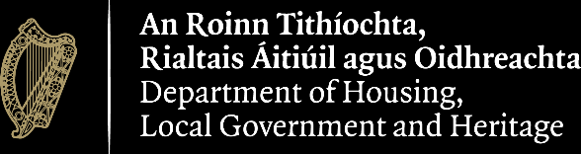
gov.ie/housing

